CS 340 README Template

Albert Waterman

About the Project/Project Title
I created this project to make a reusable Python module that implements CRUD functions for a MongoDB database. The Python module was designed to work with the Austin Animal Center (aac), with the data stored within MongoDB. I used object-oriented programming to make the code modular, readable, and reusable. This project includes a Dash-based dashboard that connects to MongoDB and displays animal shelter data through an interactive web interface.

Motivation
The motivation behind the project was to create a portable, reusable Python module that would simplify MongoDB database interaction. So instead of writing database logic repeatedly, using the CRUD module would generalize create and read operations into a single class. This improves maintainability, reduces errors, and prepares the overall project for expansion and usability. The dashboard portion of the project demonstrates how backend database logic can be cleanly integrated into a web application.

Getting Started
To get started, the user needs access to a MongoDB containing aac data. Then the user needs the right to read and write permissions under aacuser. Once this is complete, the user will be able to import the CRUD Python module into Jupyter Notebook and initiate the class to begin creating, reading, updating, and deleting data. Then the Dash dashboard can be launched to interact with the database.

Installation
Pymongo
MongoDB
Jupyter Notebook
Dash

Usage
Workflow
- Import CRUD module.
- Initiate AnimalShelter class.
- Use the create() method to insert a document.
- Use the read() method to query and return documents.
- Use the update() method to modify documents.
- Use the delete() method to delete a document
- Launch Dash dashboard to display query data

# Python Code

from pymongo import MongoClient
from bson.objectid import ObjectId

class AnimalShelter(object):
""" CRUD operations for Animal collection in MongoDB """

def __init__(self):
# Initializing the MongoClient. This helps to access the MongoDB
# databases and collections. This is hard-wired to use the aac
# database, the animals collection, and the aac user.
#
# You must edit the password below for your environment.
#
# Connection Variables
#
USER = 'aacuser'
PASS = 'Ajwaterman'
HOST = 'localhost'
PORT = 27017
DB = 'aac'
COL = 'animals'
#
# Initialize Connection
#
self.client = MongoClient('mongodb://%s:%s@%s:%d' % (USER,PASS,HOST,PORT))
self.database = self.client['%s' % (DB)]
self.collection = self.database['%s' % (COL)]

# Create a method to return the next available record number for use in the create method

# Complete this create method to implement the C in CRUD.
def create(self, data):
if data is None:
#empty data returns false
return False
try:
self.database.animals.insert_one(data)
return True
except:
return False

# Create method to implement the R in CRUD.
def read(self, query):
if query is None:
#returns empty list
return []
try:
cursor = self.database.animals.find(query) # data should be dictionary
return list(cursor)
except:
return []
# create update method
def update(self, query, newinput):
if query is None or newinput is None:
return 0
try:
result = self.database.animals.update_many(query, {"$set": newinput})
return result.modified_count
except:
return 0
#create delete method
def delete(self, query):
if query is None:
return 0
try:
result = self.database.animals.delete_many(query)
return result.deleted_count
except:
return 0

The AnimalShelter class connects to the aac database and lets me insert new records or query existing ones using simple dictionary inputs. The create() method adds a document and returns True or False depending on whether it worked, and the read() method uses find() to return matching records as a list.
The update() method lets me change existing records in the database by matching them with a query and applying new values. It uses MongoDB’s update_many() with the $set operator and returns how many records were updated. The delete() method removes records from the database by matching them with a query. It uses MongoDB’s delete_many() function and returns how many records were deleted. This setup keeps the database logic clean and reusable.

Next is the Dash setup

I built the dashboard using JupyterDash so it could run directly inside Jupyter Notebook. I imported the necessary Dash components, including dcc, html, dash_table, and dash_leaflet, to build the interface. I also used Plotly Express for the chart and Pandas to handle the MongoDB data. The dashboard connects to MongoDB through my AnimalShelter CRUD class. After authenticating with the aacuser account, it pulls data using the read() method. The results are converted into a DataFrame so they can be displayed in the DataTable.
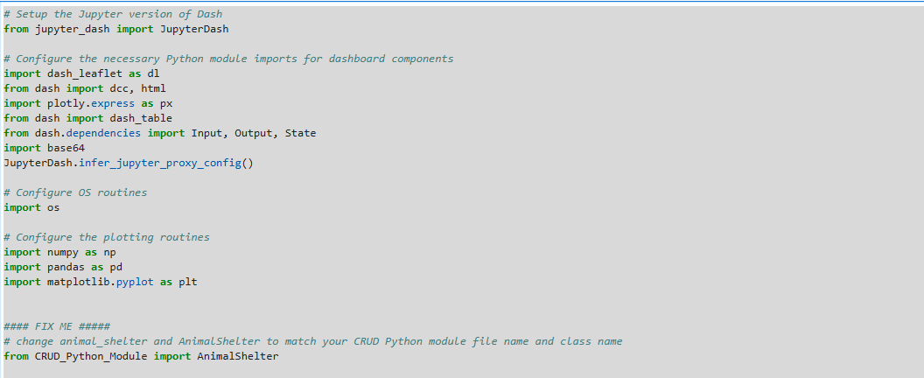

The layout includes:
• Grazioso Salvare logo
• A centered dashboard title
• Radio button filters for rescue categories
• An interactive DataTable with sorting and filtering
• A pie chart
• A geolocation map
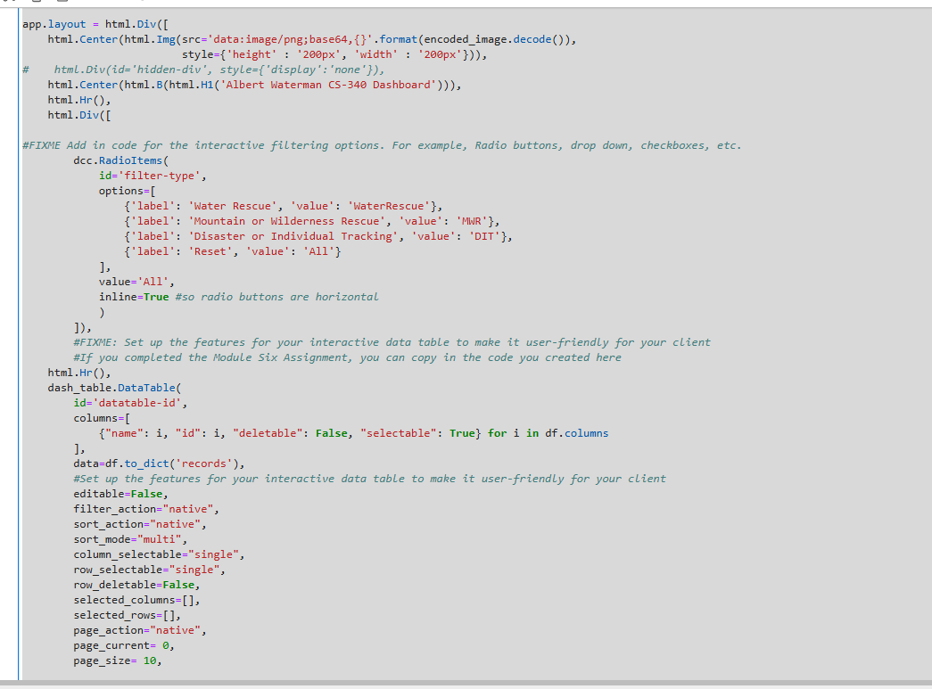
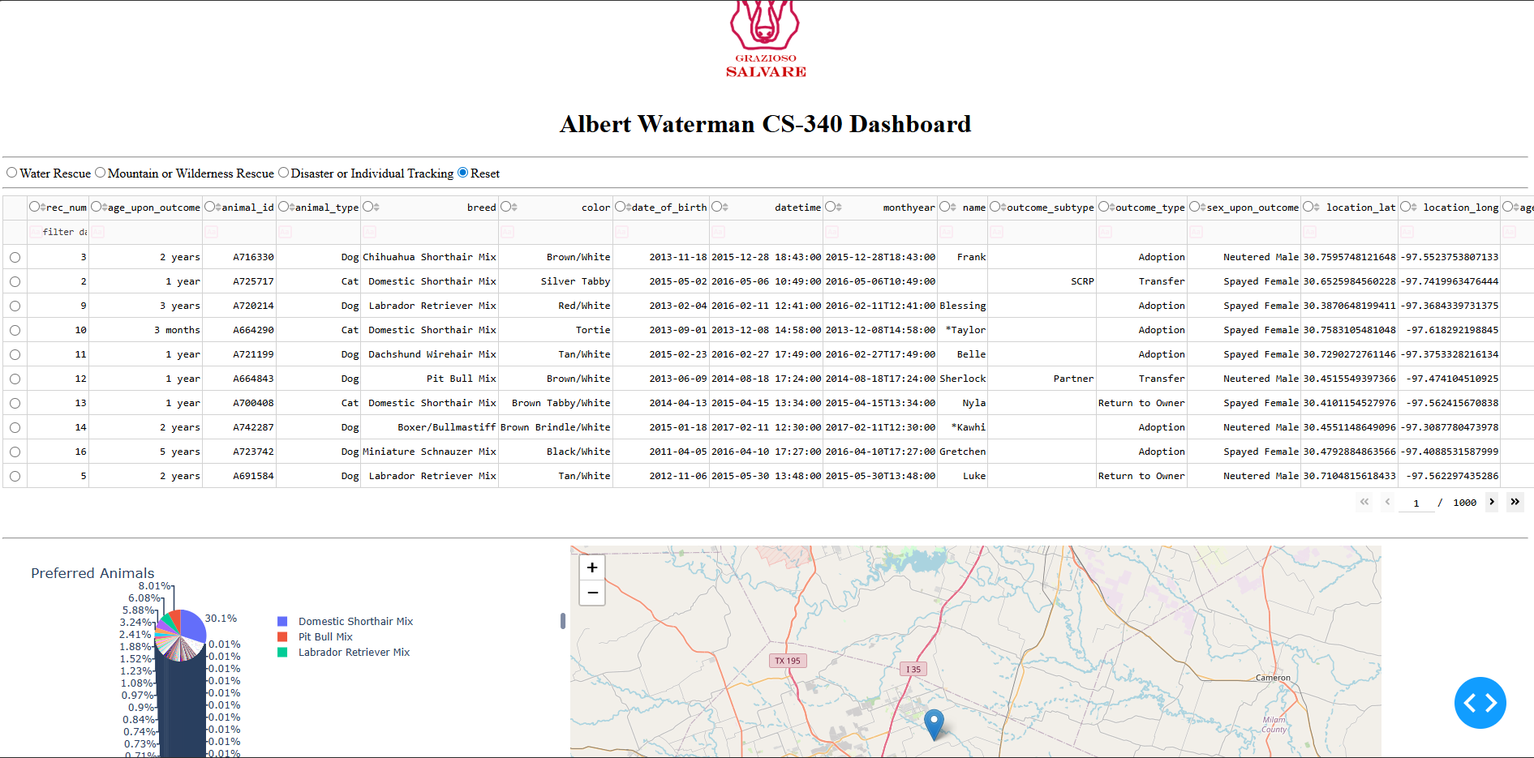
The radio buttons trigger a callback that builds a MongoDB query based on the selected rescue type. That query is passed to db.read(query), and the table updates automatically with the filtered results.
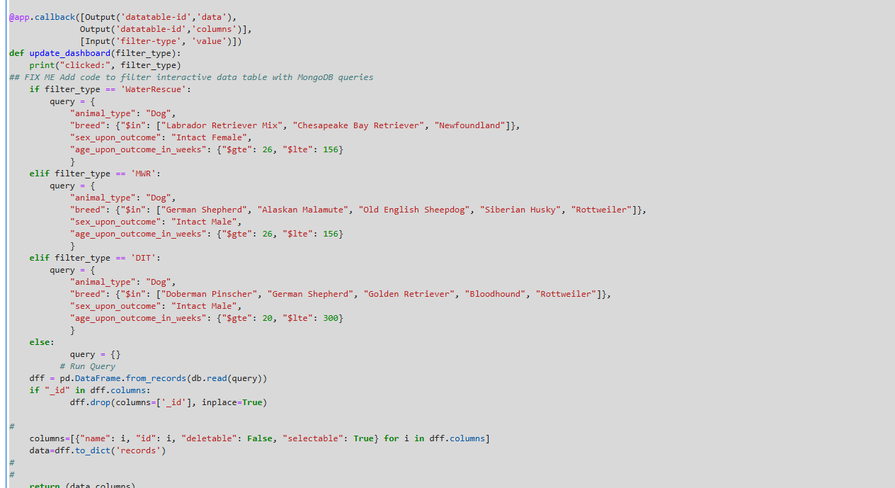
Another callback generates a pie chart showing the breed distribution of whatever data is currently visible in the table.
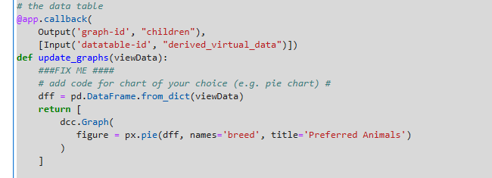
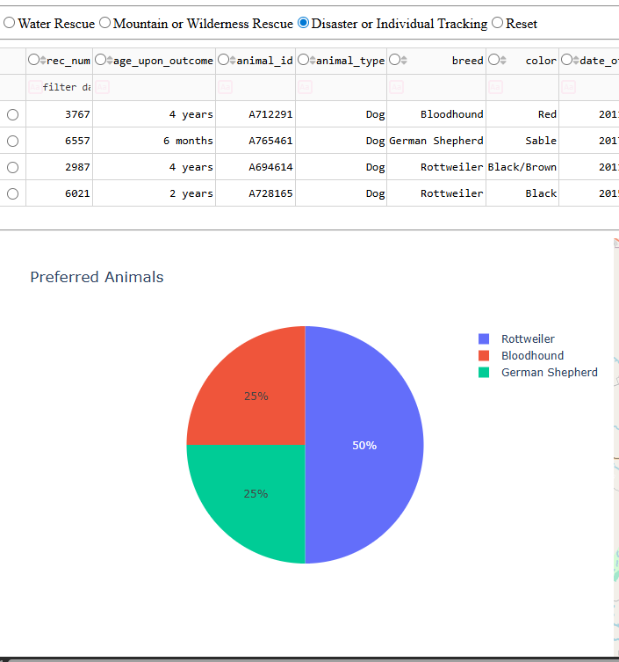
The map callback updates when a row is selected. It pulls the latitude and longitude values from that record and places a marker centered on Austin, Texas. The popup displays the animal’s name and breed.
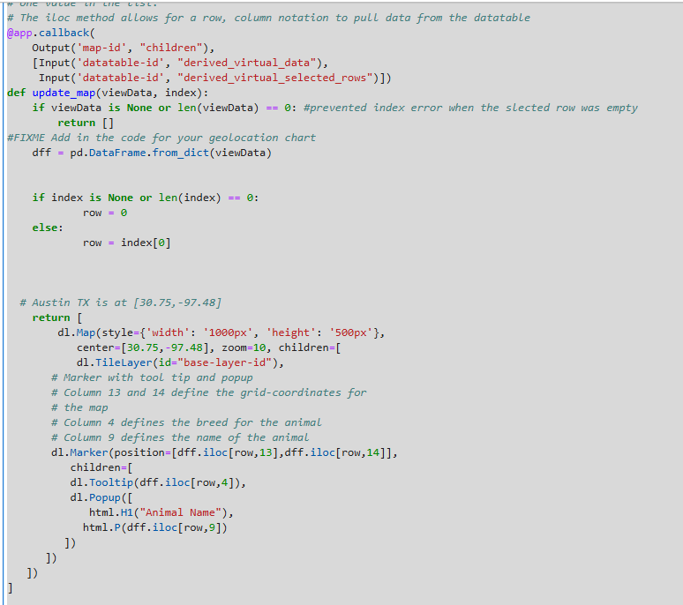
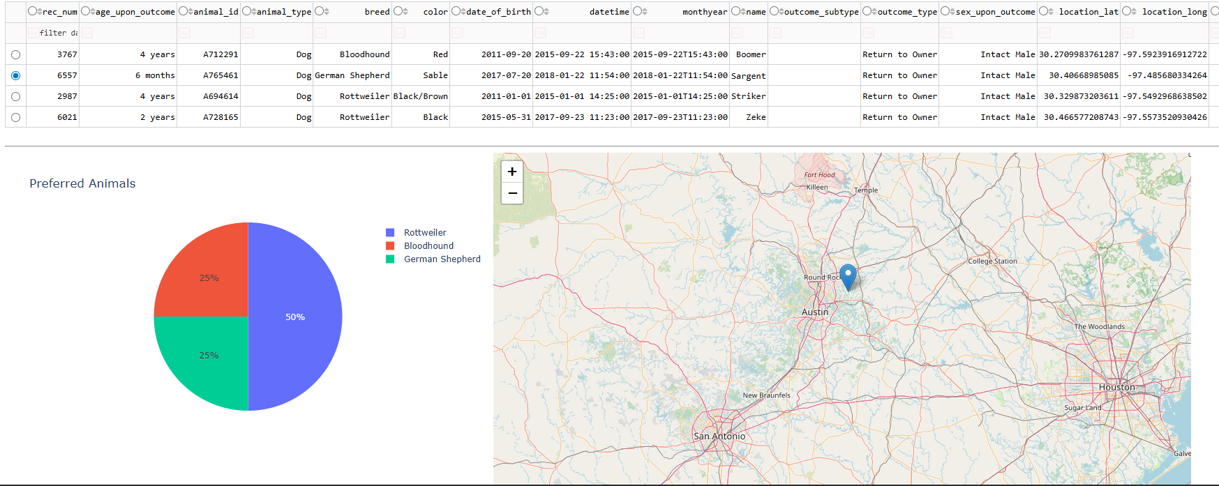
App launches using app.run_server()
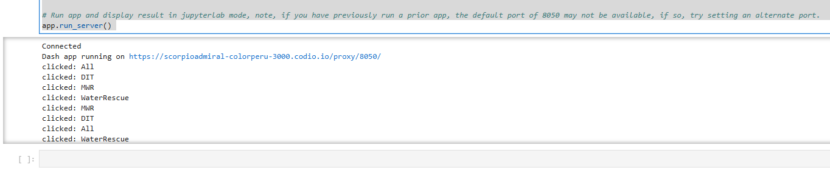
All Widget functionality
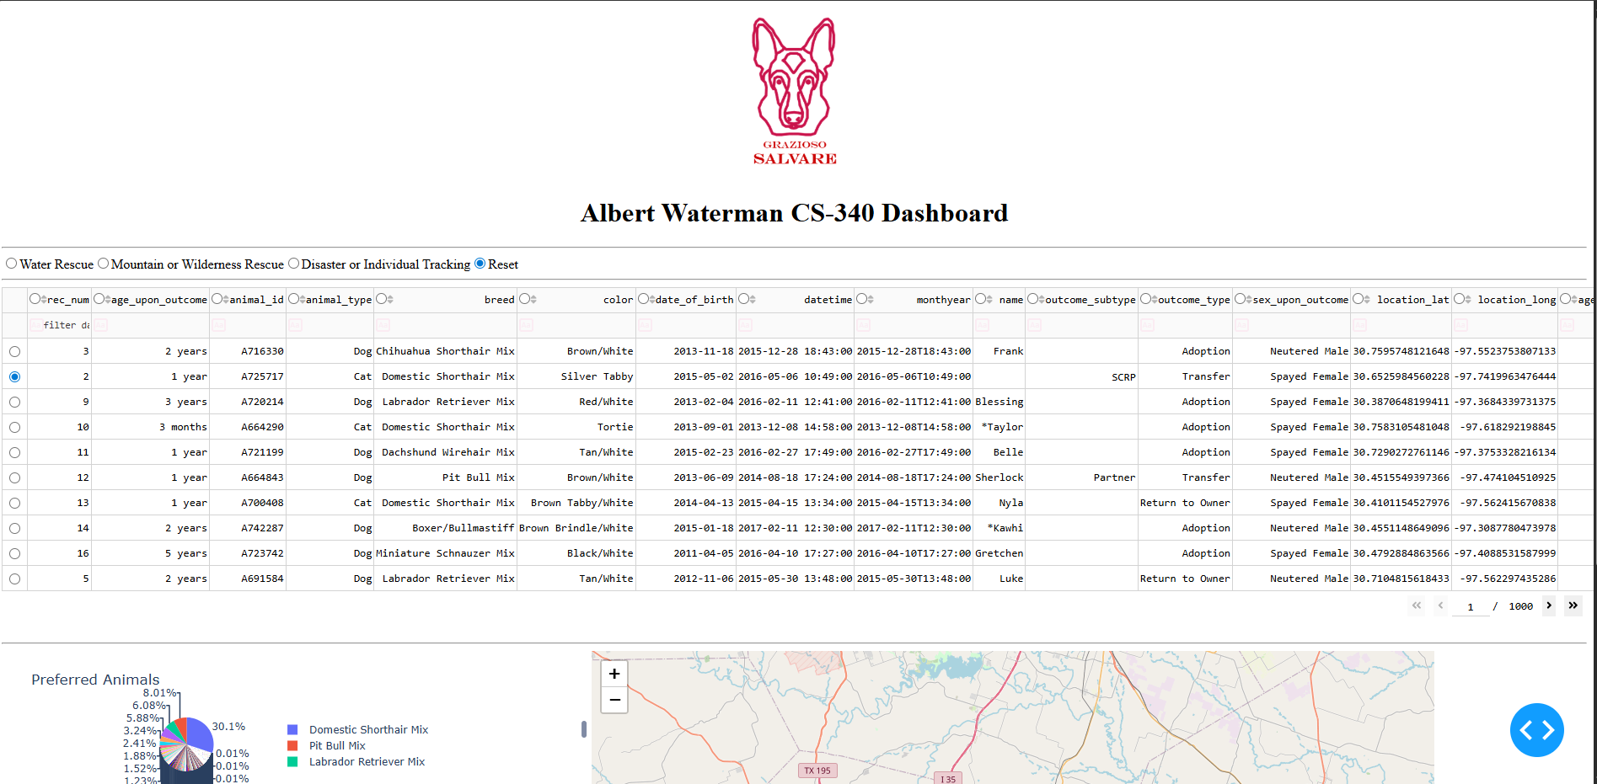
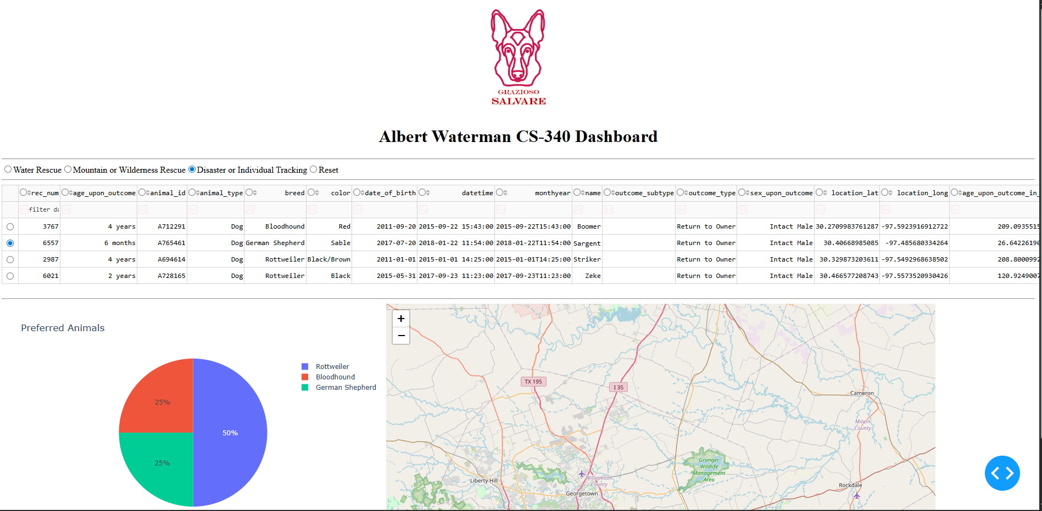
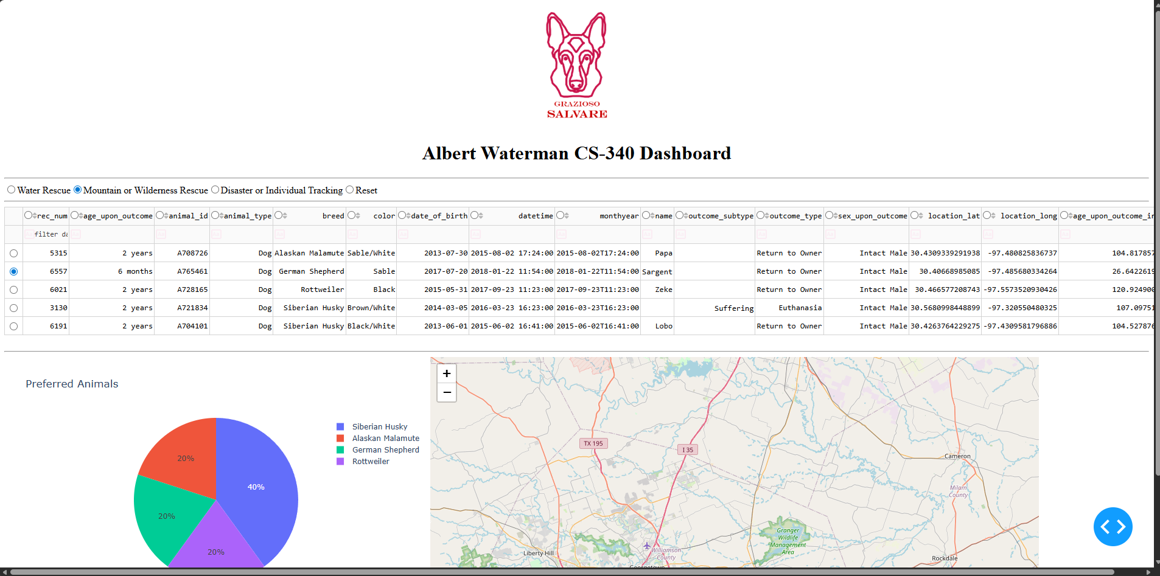
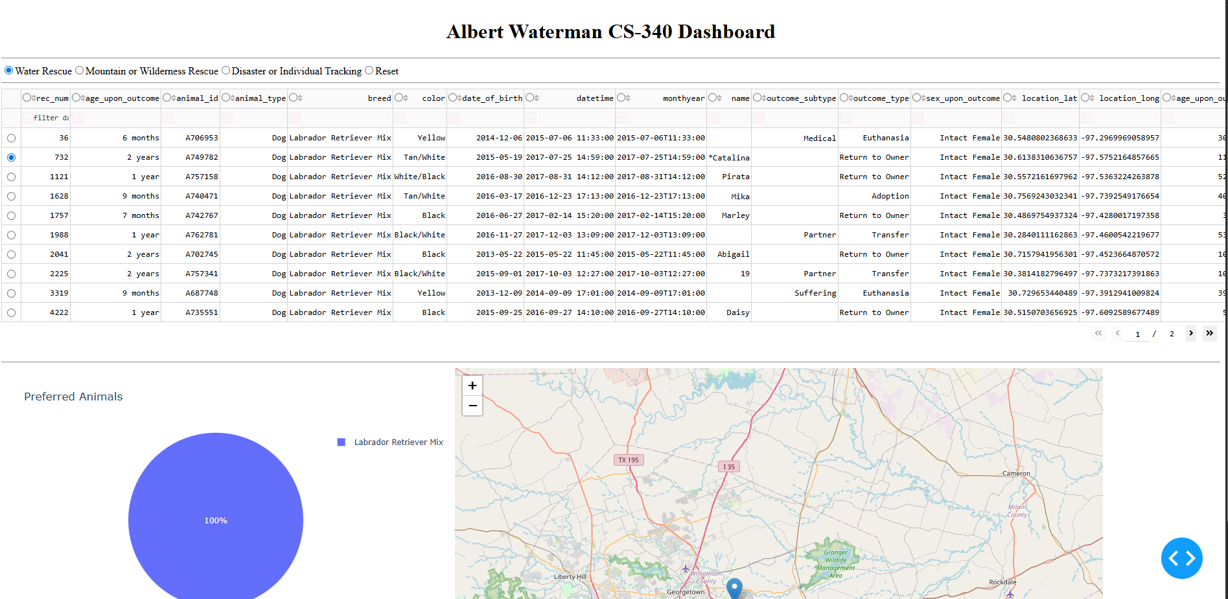

Contact
Albert Waterman
Email – albert.waterman@snhu.edu

